3.34: a) 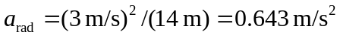, and 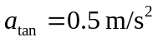. So, to the right of vertical.
b)
